Date: February 4, 2026
Client: Client A
ID#: 395830485039589
Prepared by: Megan Marshall | Managing Partner, AIIR Consulting

Ignite Executive Coaching Program
Statement of Work (SOW)
Ignite is a four-phase leadership coaching program that combines a thorough assessment of leadership styles, strengths, and areas of potential growth with a targeted executive coaching program. The primary objective of Ignite is for the client to learn how to leverage their leadership strengths and focus on critical developmental opportunities to propel their leadership capability to the next level.
The program is designed utilizing the four stage AIIR® coaching methodology for behavioral change (Assessment - Insight - Implementation - Reinforcement). There are a total of four formal stakeholder meetings.
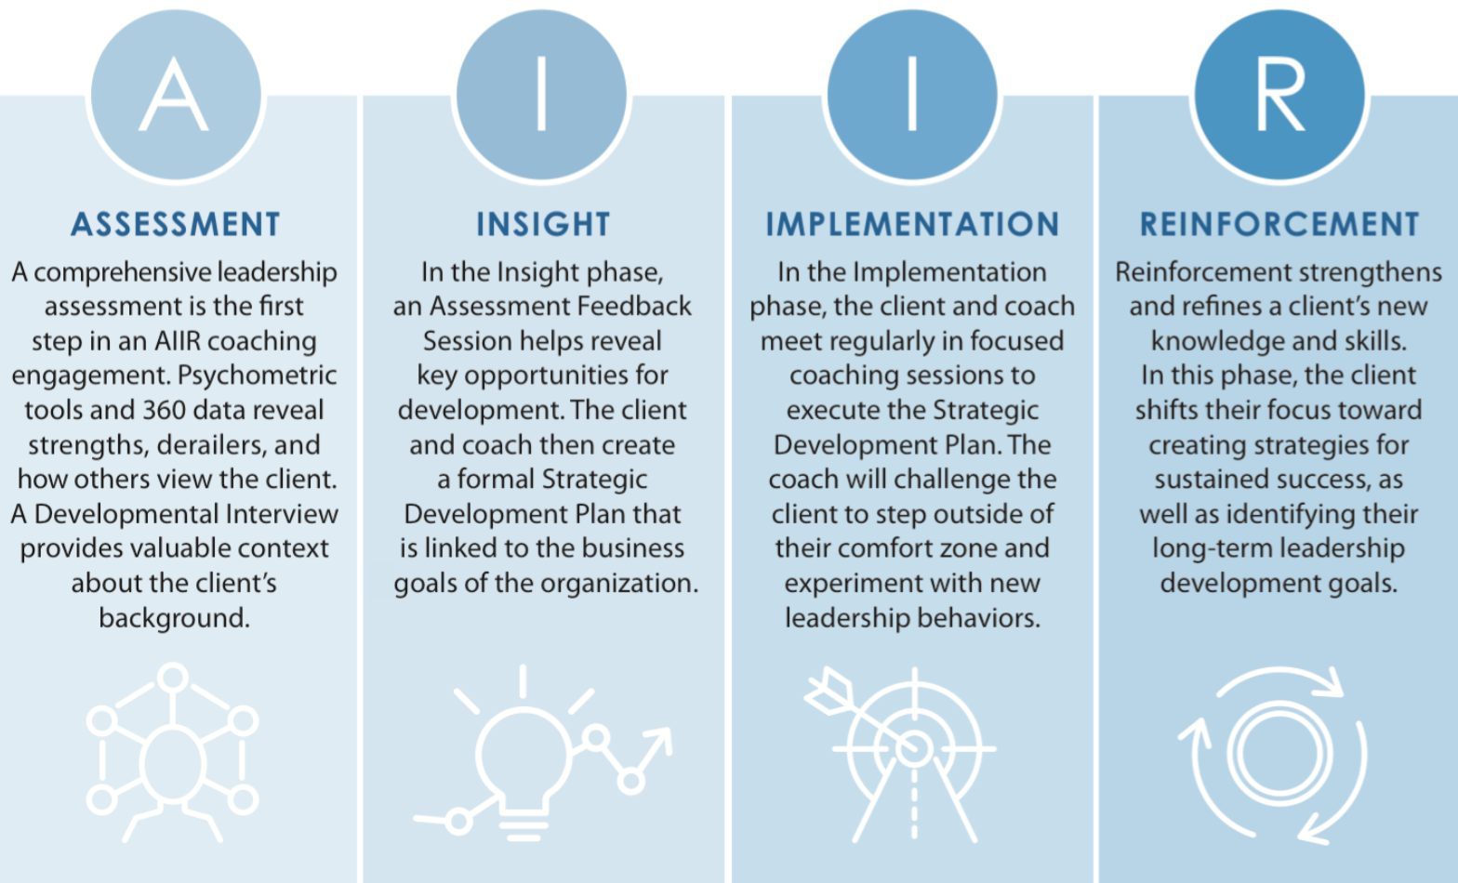
The Ignite program will take place over a six- to nine-month duration. The program will be delivered by Jonathan Kirschner, a Senior Level AIIR Consultant and leverage AIIR’s proprietary coaching technology, the Coaching Zone®.

Ignite Program Deliverables:
STAGE I: ASSESSMENT
Coaching Kickoff Session | Coach and client meet for a brief 30-minute session to formally introduce themselves. The coach shares expectations for the upcoming Agenda Setting Meeting.
Stakeholder Meeting 1: Agenda Setting Meeting (ASM) | Attended by the client, coach, and stakeholders (manager and potentially HR Business Partner). It is used to introduce the coaching program, identify areas for development, identify 360 raters, and determine metrics for success. Boundaries of confidentiality are also discussed in this meeting.
Developmental History Interview | Client and coach meet for a Developmental History Interview. This interview gathers essential baseline information about the client’s background, values, motivation, career goals, and expectations.
Interview-Based 360 ̊ Assessment | Coach conducts up to 8 confidential interviews with key raters following a customized interview protocol. Interviews are generally up to 45 minutes each.
Psychometric Assessment Battery | The client takes four psychometric, self-report assessments:  - Hogan Personality Inventory (HPI): Yields insight into how a person works, leads, and his/her general effectiveness as a leader.  - Hogan Development Survey (HDS): Describes personality dimensions that can emerge under high levels of stress and can impede relationships and performance.  - Motivations, Values, and Preferences Inventory (MVPI): Describes the goals, values, motivators, and interests that determine what an individual desires and strives to attain.  - LD12™: The LD12 assessment is the only science-backed assessment specifically designed to measure leadership skills. Insights from the assessment are distilled into concrete strengths and opportunities.  All assessments are administered online and require approximately 20 minutes each for completion.
STAGE II: INSIGHT
Integration and Analysis of Data | Coach reviews the three streams of data (360° data, psychometric results, and Developmental History Interview) and identifies key themes.
Assessment Feedback Session | Client and coach meet for an in-depth discussion of all the findings from the assessment process. This meeting is typically two-hours in duration.
Development Planning Session | Client and coach schedule a 1-hour session a week after the Assessment Feedback session to solidify the Strategic Development Plan and prepare for the 2nd stakeholder meeting.
Stakeholder Meeting 2: Presentation of Development Plan | The client presents this Strategic Development Plan in a meeting with coach and stakeholder/s for support, challenge, and mutual agreement.
STAGE III: IMPLEMENTATION
Implementation Coaching Sessions | 8 executive coaching sessions are scheduled to implement the coaching objectives, as formulated in the Strategic Development Plan. The coach and client utilize the Coaching Zone® and any other preferred means of communication to collaborate between sessions to monitor progress and goal achievement.
Stakeholder Meeting 3: Mid-point Review | The coach, client, and stakeholders schedule a meeting to evaluate the client’s progress, determine what is working and where gains still need to be demonstrated.
STAGE IV: REINFORCEMENT
Continuing Action Plan (CAP) | Following the Implementation coaching sessions, the client creates a Continuing Action Plan (CAP) to identify strategies for sustaining progress on their coaching objectives.
Stakeholder Meeting 4: Wrap-Up Session | Coach, client, and manager meet to review the CAP and the coaching experience. The coach addresses areas of progress, change and development throughout the engagement.
Business Impact Survey | At the completion of the coaching engagement, the client is sent a final survey to evaluate their leadership development growth over the course of the coaching engagement. Areas of growth and development are clearly outlined, as well as potential areas for continued development. The report is shared with AIIR’s key point of contact at the organization.

Professional Fees and Terms:
- The Ignite coaching program is offered for $27,445
- The cost of any pre-approved travel and expenses are invoiced separately with original travel receipts
- 50% of the engagement fees will be invoiced upon kick off of the engagement
- 50% of the engagement fees will be invoiced three months following the kick off of the engagement

Payment Terms:
- The program is invoiced in accordance with the terms above.
- Payments are due within 45 days of the receipt of the invoice.
- AIIR is not responsible for any payment processing fees or taxes incurred by Client A. AIIR is entitled to receive the full payment amount specified in this SOW, and any payment processing fees shall be the sole responsibility of the Client A.

Policies

Cancellation Policy:
If the engagement terminates for any reason prior to the completion of the engagement, we have the right to bill for all coaching deliverables completed. Any unused coaching deliverables already paid for at the time of termination will be credited towards a future engagement, subject to AIIR’s cancellation policy noted below. Any credit memo issued as a result of a valid cancellation will remain open for twelve (12) months from its issuance. Any open credit memos can be applied to services provided by AIIR Consulting during the period. After twelve (12) months, the credit will expire.
For additional information on coaching sessions being missed and canceled, please refer to AIIR Consulting’s Cancellation Policy.

Confidentiality Policy:
- Confidentiality is a critical component to a successful and ethical coaching engagement. AIIR consultants are highly experienced and are bound by a strict code of ethics regarding the privacy of sensitive information and data.
- In regards to psychometric assessments, all assessment input goes directly to the external assessment firms who score the instruments, and all results are securely delivered to the executive coach, who is responsible for interpreting the data, compiling the assessment report, and providing feedback. Unless otherwise agreed upon at the outset, the compiled results are shared with the client only. The Strategic Development Plan, a distillation of the key assessment findings, is shared with the boss and HR Business partner in the second stakeholder meeting.
- Unless otherwise agreed upon, all information shared by the client with the coach is considered confidential and will not be shared with organizational stakeholders.
- Regular reporting providing a high-level overview of the engagement is shared throughout the engagement by AIIR’s account management team to key organizational stakeholders.

IN WITNESS WHEREOF, the parties by their duly authorized representatives have executed this agreement as of the date set forth below:

AIIR CONSULTING, LLC Client A

By: __________________________ By: ______________________________

Name: ________________________ Name: ___________________________

Title: ________________________ Title: _____________________________

Date: ________________________ Date: _____________________________

